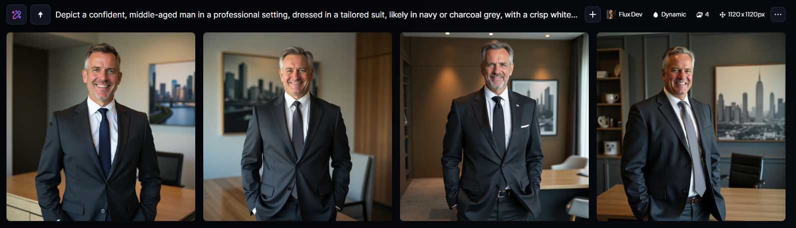

“Depict a confident, middle-aged man in a professional setting, dressed in a tailored suit, likely in navy or charcoal grey, with a crisp white dress shirt and a tie, exuding an air of authority and leadership, with a strong jawline, prominent nose, and piercing eyes that convey a sense of determination and intelligence, possibly with a hint of a smile, standing in front of a sleek, modern desk with a subtle wood grain, surrounded by minimal yet elegant office decor, with a cityscape or abstract art piece in the background, conveying a sense of sophistication and power, as the Chief Executive of a prestigious company.”

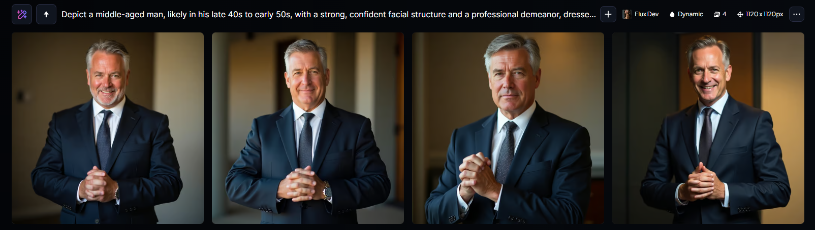

“Depict a middle-aged man, likely in his late 40s to early 50s, with a strong, confident facial structure and a professional demeanor, dressed in a tailored business suit, perhaps navy blue or charcoal grey, with a crisp white dress shirt and a subtle tie, standing in a power pose, with his hands clasped together in front of him or placed assertively on his hips, conveying authority and leadership, set against a blurred or neutral background that enhances his dominant presence, with a warm, golden lighting that accents his features, particularly his defined jawline, prominent nose, and piercing brown eyes that exude intelligence and astuteness.”  
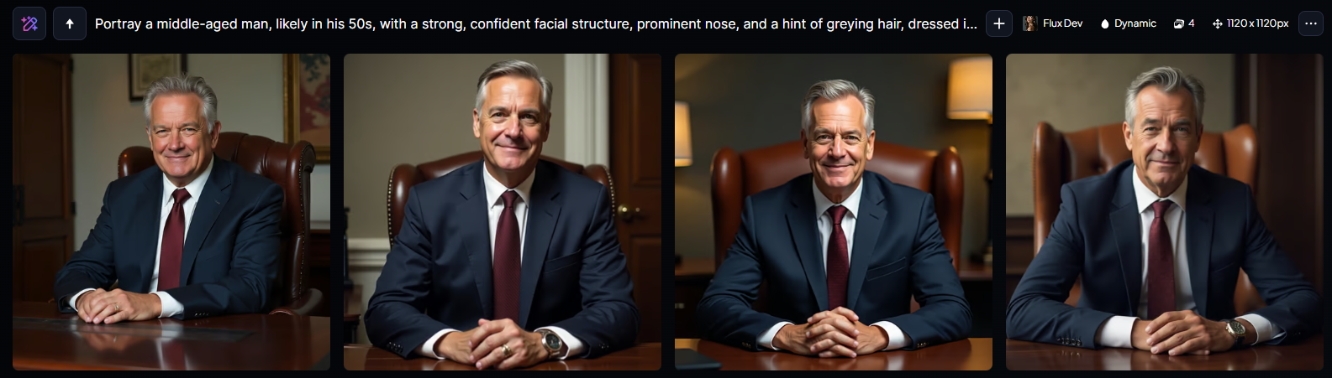

“Portray a middle-aged man, likely in his 50s, with a strong, confident facial structure, prominent nose, and a hint of greying hair, dressed in a tailored, navy blue business suit, crisp white dress shirt, and a burgundy tie, seated in a leather office chair behind a large, polished wooden desk, with a subtle, yet assertive expression, conveying a sense of authority and leadership, set against a softly lit, neutral-colored background that suggests a corporate or professional setting, with a hint of warm, earthy tones to add depth and sophistication.”